Axiom Requisition Copy Service
447 North Canal Road, Lansing, Michigan 48917
517.886.5099 – 877.886.5090 toll free – 517.886.4116 facsimile

HealthCare Ventures
Human Resources
55 Cambridge Parkway, Suite 102
Cambridge, MA 02142

Re: Amin Ladak
D.O.B.: 09/20/1974; SS#: XXX-XX-1205

Dear Custodian of Records:
By service of the attached subpoena, you are notified that the Keeper of Records of your company is requested to appear and testify on behalf of the defendant with respect to the above litigation. The deposition is scheduled for 10:00 a.m. on at Horn & Lauretti, 225 Friend Street, Suite 204, Boston, MA 02114 and we ask that the individual who will appear on behalf of your office bring any and all documents in your company’s possession, custody or control that in any way relate to the items requested on the subpoena.
If you have any questions with respect to the deposition subpoena, or will have any difficulty in attending the scheduled time as set forth above, please contact our office so that we may resolve this matter prior to the aforementioned date.
Please be advised that Massachusetts General Laws Chapter 233, Section 79A permits the introduction of records into evidence in civil cases where the records have been “certified under the pains and penalties of perjury”.
In lieu of your appearance, you may mail the requested records prior to the aforementioned date to Axiom Requisition Copy Service, 447 North Canal Road, Lansing, MI 48917. If you have any questions, please contact customer service at (877) 886-5090.
Thank you in advance for your cooperation with respect to this matter.

Very truly yours,

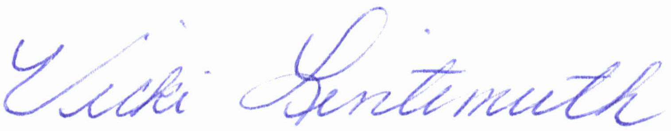
Vicki Lintemuth
MHM/vll
Enclosures
Cc: Paul J.Driscoll
Order No.: 01-17992-019

COMMONWELTH OF MASSACHUSETTS

Middlesex, SS | Superior Court  Civil Action No.: 08-4763

Amin Ladak  Plaintiff  vs.  Matthew D. Caputo  Defendant | )  )  )  )  )  )  )  ) | SUBPOENA
To: Custodian of Records
HealthCare Ventures
55 Cambridge Parkway, Suite 102
Cambridge, MA 02142

Greetings:

PLEASE NOTE: You may mail your records to: John M. Horn, Esquire, c/o Axiom Requisition Copy Service, 447 North Canal Road, Lansing, MI 48917 prior to the deposition date. If you have any questions, please contact Customer Service at (877) 886-5090.

You are hereby commanded, in the name of The Commonwealth of Massachusetts, to appear for a deposition at Horn & Lauretti, 225 Friend Street, Suite 204 , Boston, MA 02114, on , at 10:00 a.m. in the forenoon, and from day to day thereafter, until the action hereinafter named is heard, to give evidence of what you know relating to an action of tort then and there to be heard and tried between the above-named parties.

YOU ARE FURTHER REQUIRED TO BRING WITH YOU:
PLEASE REFER TO SCHEDULE "A" ATTACHED

Hereof fail not, as you will answer your default under the pains and penalties in the law in that behalf made and provided.

Dated at ____________the ______day of ___________________.

Notary Public
My Commission Expires:
Order No. 01-17992-019

Custodian of Records
HealthCare Ventures
RE: Amin Ladak
Page Two

SCHEDULE “A”

The term "document" means the original and any copy, regardless of origin or location, of any written, recorded, transcribed, punched, taped, filmed or graphic matter, however produced or reproduced, including, but not limited to, any telegram, book, letter, memorandum, report, record, study, handwritten notes, working paper, calculation, analysis, test result, charge, paper, graph, index, tape, disc, data sheet, data processing card, diary, log or logbook, minutes of corporate meetings, minutes of municipal, state or federal governmental hearings, transcript, financial record, corporate record, cancelled check, photograph, contract, architectural or engineering plans and/or specifications, sketches, diagrams, schematics, regardless of point of origin of source, maps, correspondence, drawing, policy statement, rule, regulations, guide, newspaper and magazine and other publication and clipping consultants, summaries of reports of investigation or negotiations, and all other writings.

You are hereby required to produce at the time and place of the deposition the following documents:

- FROM 1995 TO PRESENT * EMPLOYMENT AND/OR INDEPENDENT CONTRACTOR RECORDS: And you are further required to bring with you CERTIFIED COPIES of any and all records of any and every nature whatsoever concerning employment of the plaintiff. Said records must include, but not be limited to, all applications for employment, wage and salary records, performance reviews, attendance records, claims for injuries and/or disability, termination records, correspondence, and any and all other records of every kind and nature whatsoever regarding: Amin Ladak SSN:XXX-XX-1205, DOB: 09/20/1974.. Now or formerly of: 126 Fourth Street, Medford, MA.

This summons is not limited in time or scope.

Order No. 01-17992-019

